**Distilled Water Management System**

**ABSTRACT:**

Water, the essence of life, is an indispensable necessity, without which the mere thought of survival seems implausible. Despite the Earth being blessed with a vast amount of water, a substantial portion of it remains non-potable due to the presence of various salts and impurities that render it unfit for human consumption. For human beings, the vital requirement is access to potable water, free from harmful contaminants. To address this scarcity and cater to the need for drinkable water, a sophisticated system comes to our aid - the distillation process. Distillation emerges as the savior, capable of transforming brackish or salty water into safe, purified drinking water, while retaining essential minerals beneficial for human health. This revolutionary method enables us to harness and utilize fresh water sources that were previously untapped, unlocking a new potential for meeting our water demands.

The "Distilled Water Management System" is a comprehensive software project that leverages the power of Java and MySQL to create an efficient and user-friendly platform for managing the production, distribution, and utilization of distilled water. The system is designed to streamline operations and enhance overall productivity, catering to the needs of different user roles, including Admin, Users, Tester, and Transporter. The project's core objective is to optimize the entire distilled water supply chain, from production to consumption, while ensuring the highest quality and adherence to regulatory standards. The system is built on Java, providing a robust and scalable foundation for seamless functionality, and utilizes MySQL as the backend database to ensure data integrity and efficient storage. The Distilled Water Management System embraces cutting-edge technology to empower stakeholders with the right information at the right time, enabling data-driven decisions and promoting sustainable water management practices. By integrating Java and MySQL, the project delivers a secure, responsive, and seamless experience, ensuring the reliable supply of high-quality distilled water to consumers while optimizing the entire supply chain. With a focus on flexibility, scalability, and user-centric design, this unique software solution serves as a critical tool for water management authorities and organizations seeking to revolutionize their distilled water distribution process, reducing waste, and improving overall operational efficiency.

**EXISTING SYSTEM:**

* The existing system of Distilled Water Management relies on manual processes for managing the complete order and testing procedures. As a result, it can be quite challenging for the producer to handle all aspects efficiently. The reliance on manual methods and paperwork hinders the producer's ability to have a comprehensive overview of the entire system.
* In the existing system the producer faces significant challenges in managing the entire sales and testing process due to its reliance on manual procedures. The absence of an automated system makes it burdensome for the owner/producer to efficiently oversee every aspect of the existing process. With tasks predominantly paper-based and manual, the producer's ability to gain a comprehensive view of the entire system is limited.
* In the existing system, On the customer side, the existing system necessitates complete reliance on manual processes when purchasing distilled water products. This means that customers have to engage directly with the producer or designated outlets to make their purchases. This level of dependency on manual interactions can lead to longer waiting times and potential inconveniences for the customers
* Moreover, the manual nature of the existing process introduces time-consuming factors. Tasks such as record-keeping and data entry demand considerable effort and are susceptible to human errors. As a result, customers who choose to engage in direct shopping may find it challenging to access crucial information, such as price ranges and available product items, leading to a less informed shopping experience.
* Overall, the existing manual system, while functional, presents challenges in terms of efficiency, customer experience, and management visibility. An automated and digital solution could address these issues and improve the overall distilled water management process, providing a seamless experience for both producers and consumers.

**DISADVANTAGES OF EXISTING SYSTEM:**

* Inefficiency: The manual nature of the existing system can lead to inefficiencies in managing sales, testing, and other processes. The reliance on paper-based documentation and manual data entry can result in delays, errors, and redundant tasks, impacting overall productivity.
* Limited Visibility: Due to the absence of an integrated and automated system, the producer faces challenges in obtaining a comprehensive view of the entire water management process. This lack of real-time data and analytics hinders the ability to make well-informed decisions promptly.
* Customer Inconvenience: Customers relying on manual processes for purchasing distilled water may encounter longer waiting times and inconvenience. The need for direct interactions with producers or retailers can lead to a less seamless and time-consuming shopping experience.
* Manual Errors: Human errors in manual data entry, record-keeping, and communication can occur, potentially leading to inaccurate information and mismanagement of critical aspects of the water management system.
* Limited Accessibility: The absence of digital platforms restricts customers' access to essential information such as product details, price ranges, and availability. This lack of transparency may hinder customer satisfaction and loyalty.
* Difficulty in Scaling: As demand for distilled water grows, the existing manual system may struggle to scale up effectively. Manual processes could become overwhelmed, leading to operational challenges and potential service disruptions.
* Compliance and Reporting Issues: Manual record-keeping may raise concerns regarding adherence to regulatory standards and reporting requirements. The absence of automated tracking and reporting mechanisms could make compliance more challenging.
* Dependency on Individuals: The smooth functioning of the existing system heavily relies on the knowledge and expertise of specific individuals involved in the manual processes. Any disruptions caused by personnel changes or absences could impact the system's effectiveness.
* Lack of Innovation: The reliance on manual methods can hinder the adoption of innovative technologies and practices that could optimize the water management process and improve overall efficiency.
* Data Security Concerns: Paper-based documentation raises data security and privacy concerns, as sensitive information may be susceptible to loss, theft, or unauthorized access.

To address these disadvantages and improve distilled water management, the implementation of automated and digital solutions is essential. Transitioning to a more technologically advanced system can enhance efficiency, transparency, and customer satisfaction while promoting sustainable water management practices.

**PROPOSED SYSTEM:**

* The proposed system for Distilled Water Management is a comprehensive and innovative solution that aims to revolutionize the entire process of producing, distributing, and delivering purified water. Leveraging cutting-edge technology and automation, the proposed system addresses the limitations of the existing manual system and offers an array of functionalities to ensure efficiency, transparency, and customer satisfaction.
* The proposed system is developed to overcome the disadvantages of the existing system and optimize the Distilled Water Management System, a modern and automated approach could be implemented. By introducing digital solutions, the sales and testing processes can be streamlined, alleviating the burden on producers and enhancing their visibility over the entire system. Additionally, automated purchasing options could empower customers, providing them with convenient access to product information and a seamless shopping experience. The integration of technology in the existing system promises to revolutionize distilled water management, making it more efficient, customer-friendly, and ultimately, ensuring a reliable supply of safe drinking water for all.
* The proposed system streamlines the sales and testing processes through automation. Producers can easily manage and track sales, orders, and inventory in real-time using a user-friendly interface. Automated water quality testing ensures accurate and consistent results, eliminating the need for manual evaluations.
* With an integrated tracking system, producers can monitor the entire water management process in real-time. From production to delivery, the system provides comprehensive insights and generates detailed reports, empowering producers to make data-driven decisions.

**ADVANTAGES OF PROPOSED SYSTEM:**

* Increased Efficiency: By automating various processes such as sales, testing, and inventory management, the proposed system streamlines operations, reducing manual effort and saving valuable time for producers and other stakeholders.
* Enhanced Customer Experience: Through digital platforms and user-friendly interfaces, the proposed system empowers customers with convenient ordering options, access to product information, and transparent pricing, resulting in an improved and seamless shopping experience.
* Real-Time Tracking and Monitoring: With integrated tracking and monitoring features, the proposed system enables real-time visibility into the entire water management process. Producers and transporters can track deliveries, water quality, and production status, ensuring efficient logistics and timely responses to any issues.
* Data-Driven Decision Making: The system's data analytics capabilities provide valuable insights into customer behavior, demand patterns, and production efficiency. This enables producers to make informed decisions, optimize resources, and adapt to market trends effectively.
* Improved Water Quality Management: The proposed system incorporates advanced sensors and monitoring devices to continuously assess water quality. Producers receive instant alerts for deviations, enabling prompt corrective actions and ensuring consistent high-quality distilled water.
* Scalability and Flexibility: The web-based infrastructure of the proposed system allows for easy scalability, accommodating future growth and adapting to changing demands and requirements.
* Centralized Data Management: The proposed system centralizes data storage and management, making it easier for authorized users to access essential information from any location, promoting collaboration and coordination.
* Regulatory Compliance: The system's automated tracking and reporting features facilitate adherence to regulatory standards, ensuring that the production and distribution processes comply with relevant guidelines and requirements.
* Reduced Paperwork: By reducing reliance on paper-based documentation, the proposed system contributes to environmental conservation while streamlining administrative tasks for improved productivity.
* Training and Support: The system provides comprehensive training and ongoing support to all stakeholders, ensuring smooth adoption and maximizing the benefits of the proposed system.

In conclusion, the advantages of the proposed system for Distilled Water Management encompass enhanced efficiency, customer satisfaction, data-driven decision-making, and streamlined operations, making it a transformative solution to meet the demands of modern water management practices. The integration of advanced technology promises to elevate the distilled water industry, promoting sustainability, transparency, and accessibility for producers and consumers alike.

**SYSTEM ARCHITECTURE:**

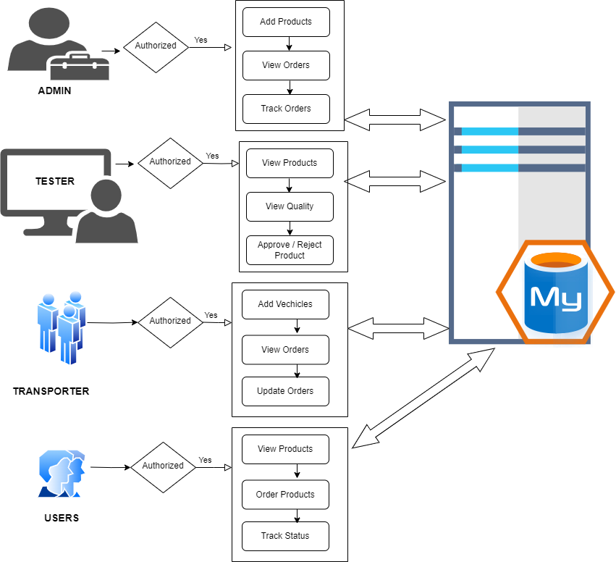

**MODULES:**

* Admin Module
* Users Module
* Tester Module
* Transporter Module

**MODULES DESCSRIPTION:**

**Admin Module:**

The Admin module is the core administrative component of the Distilled Water Management System, equipped with robust features to oversee and manage the entire system. The module is accessible only to authorized administrators who hold administrative privileges. Key functionalities include:

Product and Pricing Management: The Admin has the authority to add distilled water products from the system. They can also set and update pricing information, ensuring accurate and up-to-date product listings. Whenever admin adds new product it will not be displayed to the user immediately. Only after the tester has tested and approved the product only, the user can view the product and also the admin can see it in the View added products. If the tester has rejected it, then it will not be given to any one.

Order Management: Admins can view and manage all incoming orders from Users, facilitating efficient order processing and fulfillment.

Quality Control: The Admin oversees the testing process and can review quality reports generated by Testers. In case of any water quality issues, the Admin can take appropriate actions to rectify them.

Transports: Once after receiving the order from the user, the admin approves it and then assigns the transporter for the particular order.

**Users Module:**

The Users module caters to the end-users and customers who rely on the Distilled Water Management System to purchase purified water. Key features of this module include:

User Registration and Authentication: New customers can create accounts by registering with their relevant details, and existing users can log in securely using their credentials.

Product Catalog: Users can access a user-friendly catalog displaying available distilled water products, along with their descriptions, pricing, and other relevant details.

Ordering and Payment: Customers can place orders for distilled water through the system. The cost calculation is made automatically and updated according to the number of products the user has selected. Additionally the Tax calculation is also done by the system.

Order Tracking: Users can track the status of their orders in real-time, from processing to delivery, providing them with visibility and assurance about their purchases.

**Tester Module:**

The Tester module is dedicated to professionals responsible for testing the quality of distilled water before it is approved for distribution. Key functionalities of this module include:

Quality Reports: Testers generate detailed quality reports based on the testing results, providing valuable data for Admins and producers to make informed decisions.

**Transporter Module:**

The Transporter module is designed for the efficient management of water delivery and logistics. Transporters involved in the distribution process gain access to the following functionalities:

Login: In our transporter module we have created 3 default transporters with the name: T1, T2, T3. There transporters only will transport and deliver the water orders which is assigned by the admin. Only the admin assigns the Transporter for the particular order.

Order Assignment: The Transporter module receives information about assigned orders and delivery schedules, ensuring a seamless and organized distribution process.

Delivery Status Updates: Transporters can update the status of each delivery in real-time, allowing Users to track the progress of their orders.

**SYSTEM REQUIREMENTS:**

**HARDWARE REQUIREMENTS:**

* System : Pentium i3 Processor
* Hard Disk : 500 GB.
* Monitor : 15’’ LED
* Input Devices : Keyboard, Mouse
* Ram : 4 GB

**SOFTWARE REQUIREMENTS:**

* Operating system : Windows 10/11.
* Coding Language : JAVA.
* Tool : Apache Netbeans IDE 16.
* Database : MYSQL